**Index**

|  |  |  |  |
| --- | --- | --- | --- |
| **Sl. No.** | **Name of Experiment** | **Date** | **Signature** |
| 1 | Generate AND, NOT function using McCulloch-Pitts neural net by MATLABprogram. |  |  |
| 2 | Write a MATLAB program for Perceptron net for an AND function with bipolarinputs and targets. |  |  |
| 3 | Write a MATLAB Program on Back propagation neural network. |  |  |
| 4 | Write a program in MATLAB to plot various membership functions. |  |  |
| 5 | Use Fuzzy toolbox to model tip value based on service and food quality. |  |  |
| 6 | Implement FIS Editor. |  |  |
| 7 | Write a MATLAB Program on Basic Operations of Genetic Algorithm. |  |  |
| 8 | Basic Understanding of Prolog Programming. |  |  |

**Experiment No. 1:**

**Title: Generate AND, NOT function using McCulloch-Pitts neural net by MATLAB program.**

**Aim:** Write down briefly about the importance/ applicability of McCulloch-Pitts neural net.

**Theory:** Write it as taught in the class.

**Matlab Code:**

%AND function using McCulloch-Pitts Neuron

clc

clear all

%close all

%Getting weights & Threshold value

disp('Enter the weights');

w1 = input('Weight w1=');

w2 = input('Weight w2=');

disp('Enter the Threshold value');

theta = input('Theta=');

y = [0 0 0 0];%initialize to avoid garbage value

x1 = [0 0 1 1];%Input1

x2 = [0 1 0 1];%input2

z = [0 0 0 1];%ideal output

zin = x1*w1+x2*w2;

for i=1:4

if zin(i)>=theta

y(i)=1;

else y(i)=0;

end

end

disp('Output of net=');

disp(y);

if y==z

disp('Net is Learning properly');

else

disp('Net is not Learning properly');

end

%NOT function using McCulloch-Pitts Neuron

clc

clear all

%close all

%Getting weights & Threshold value

disp('Enter the weights');

w1 = input('Weight w1=');

disp('Enter the Threshold value');

theta = input('Theta=');

y = [0 0];%initialize to avoid garbage value

x1 = [0 1];%Input1

z = [1 0];%ideal output

zin = x1*w1;

for i=1:2

if zin(i)>=theta

y(i)=0;

else y(i)=1;

end

end

disp('Output of net=');

disp(y);

if y==z

disp('Net is Learning properly');

else

disp('Net is not Learning properly');

end

**Results:**

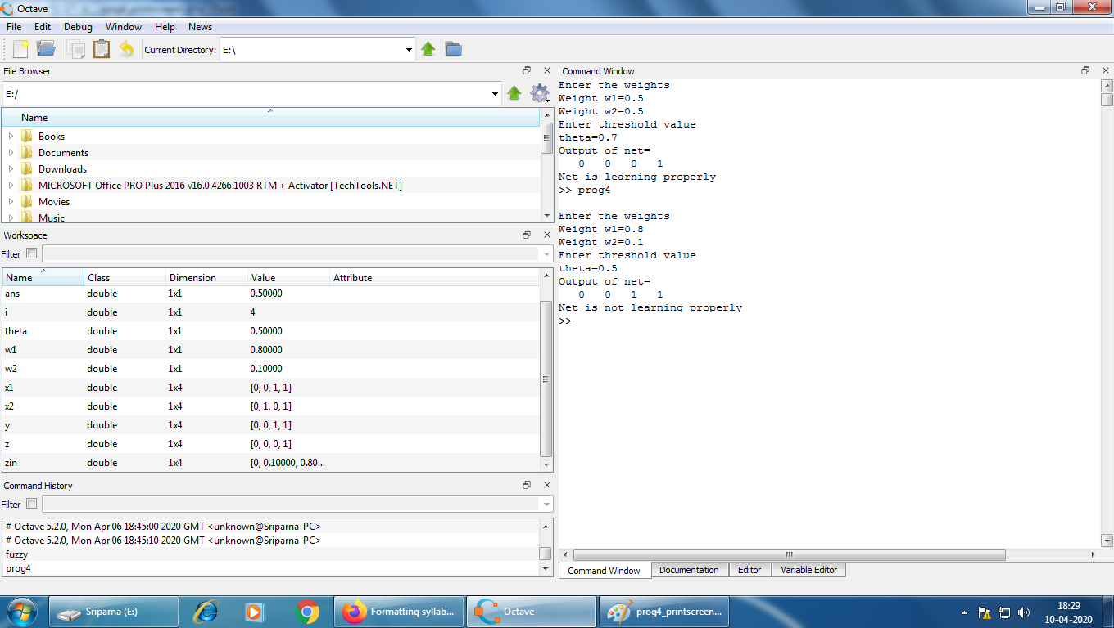

**Conclusion:**

**Reference:**

https://www.youtube.com/watch?v=6XhSJbfT1pk

**Experiment No. 2:**

**Title: Write a MATLAB program for Perceptron net for an AND function with bipolar inputs and targets.**

**Aim:** Write down briefly about the importance/ applicability of Perceptron net.

**Theory:** Write it as taught in the class.

**Matlab Code:**

% Perceptron for AND Function

clear;

clc;

x=[1 1 -1 -1;1 -1 1 -1];

t=[1 -1 -1 -1];

w=[0 0];

b=0;

alpha=input('Enter Learning rate=');

theta=input('Enter Threshold Value=');

con=1;

epoch=0;

while con

con=0;

for i=1:4

yin=b+x(1,i)*w(1)+x(2,i)*w(2);

if yin>theta

y=1;

end

if yin<=theta && yin>=-theta

y=0;

end

if yin<-theta

y=-1;

end

if y-t(i)

con=1;

for j=1:2

w(j)=w(j)+alpha*t(i)*x(j,i);

end

b=b+alpha*t(i);

end

end

epoch=epoch+1;

end

disp('Perceptron for AND Function');

disp('Final Weight Matrix');

disp(w);

disp('Final Bias');

disp(b);

**Results:**

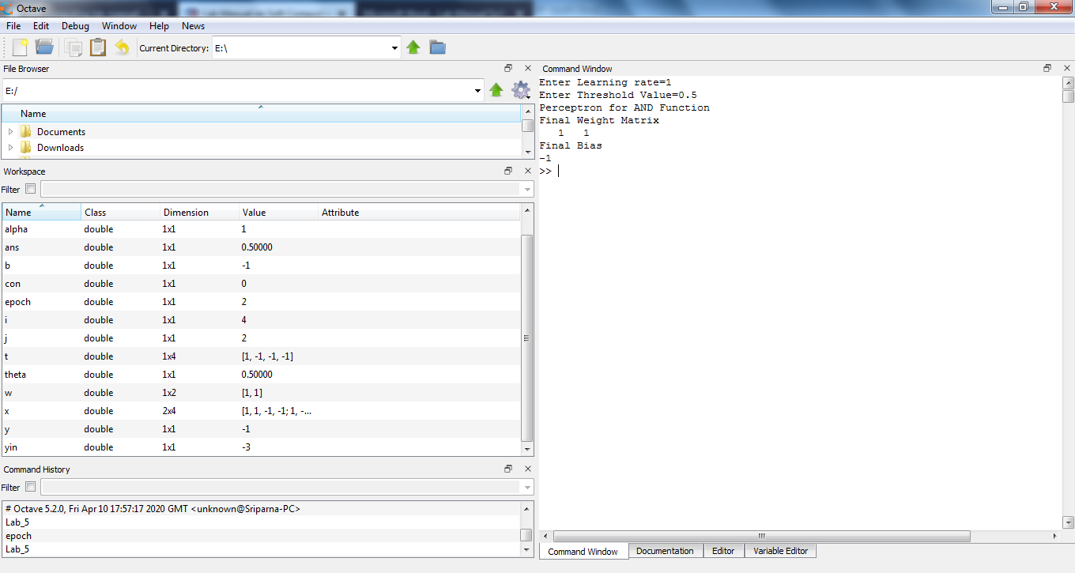

**Conclusion:**

**Reference:**

https://www.youtube.com/watch?v=VRcixOuG-TU

**Experiment No. 3**

**Title: Write a MATLAB Program on Back propagation neural network.**

**Aim:** Write down briefly about the importance/ applicability of back propagation neural network.

**Theory:** Write it as taught in the class.

**Matlab Code:**

clear all;

close all;

clc;

input=xlsread('fv.xlsx');

target=xlsread('target.xlsx');

nntic=tic;

hiddenLayerSize = 10;

net = feedforwardnet(hiddenLayerSize,'traingd');

net.trainParam.lr = 0.05; %its not mandatory to give this value, automatic value will be taken

net.trainParam.epochs = 3000; %its not mandatory to give this value, automatic value will be taken

net.trainParam.goal = 1e-5; %its not mandatory to give this value, automatic value will be taken

net.divideParam.trainRatio = 70/100;

net.divideParam.valRatio = 15/100;

net.divideParam.testRatio = 15/100;

net=init(net);

[net,tr] = train(net,input,target); %training

output = sim(net,input); %simulation

figure,plotconfusion(target,output)

plotregression(target,output); %regresson plot

error = gsubtract(target,output);

performance = mse(error); %mean square error

figure, plotroc(target,output)

nntime=toc(nntic);

unknown=xlsread('unknown.xlsx');%let it is the unknown feature value

y = net(unknown);%results obtained for all classes

% initlay is a network initialization function that initializes each layer i according to

% its own initialization function net.layers{i}.initFcn.

% The weights and biases of each layer i are initialized according to net.layers{i}.initFcn.

**Results:**

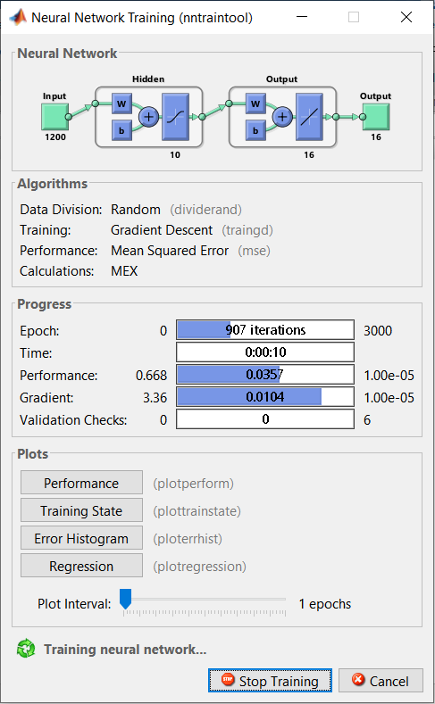 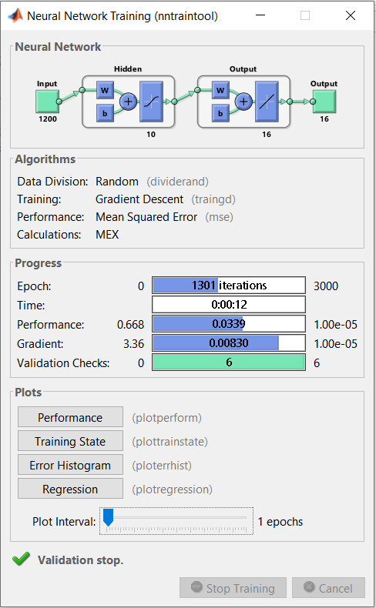

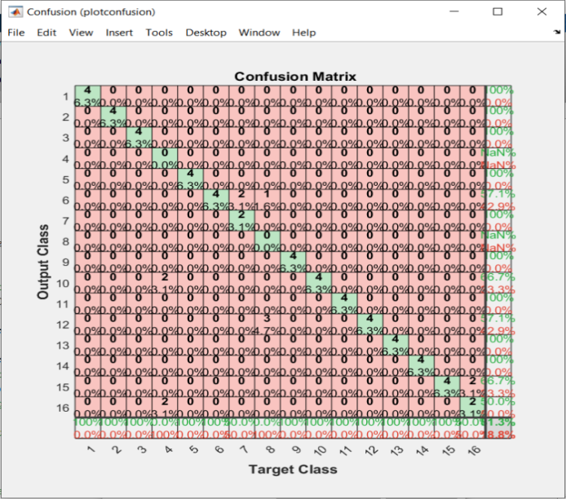 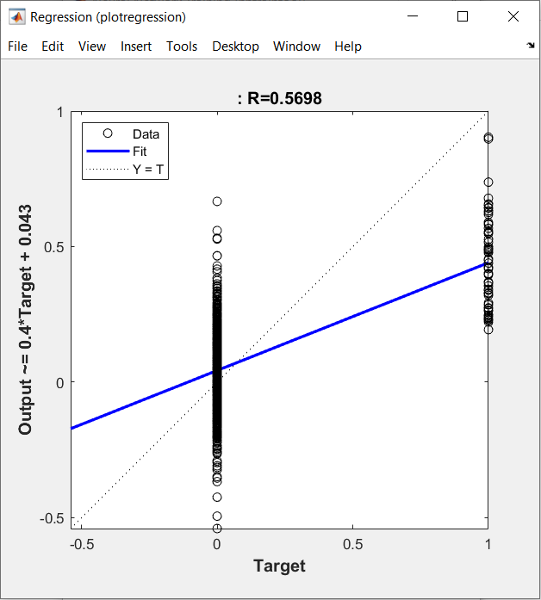

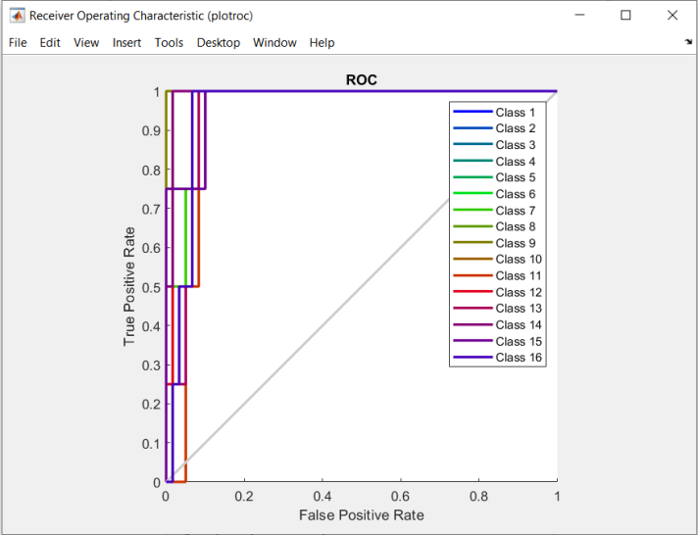 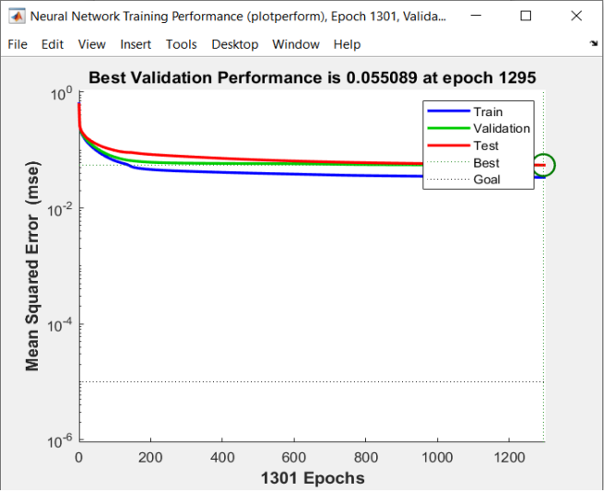

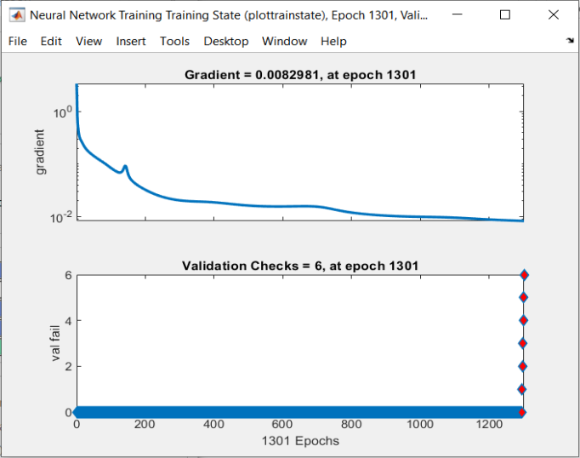 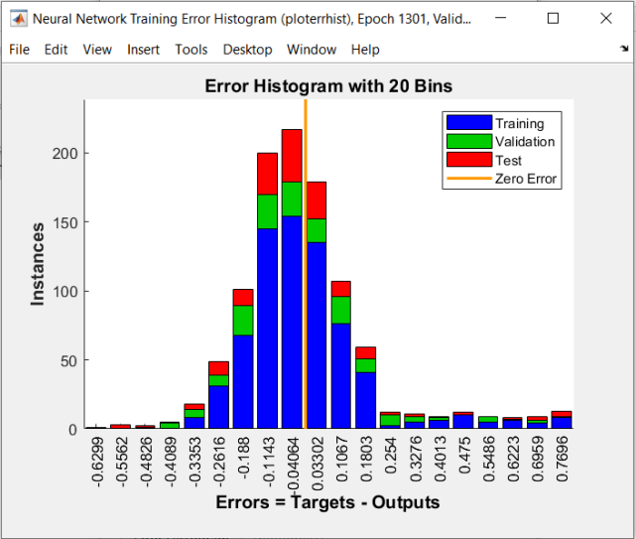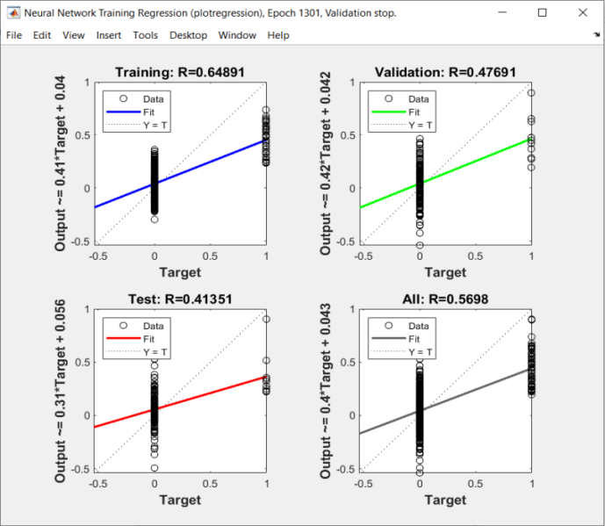

**Conclusion:**

**Reference:**

https://www.youtube.com/watch?v=PEmSbdC4y_Y&list=PLsEIbHOtypISN0ZXjZ7Uhp0YwCToyrOLM

**Experiment No. 4:**

**Title: Write a program in MATLAB to plot various membership functions.**

**Aim:** Write down briefly about importance/ applicability of membership functions.

**Theory:** You are supposed to explain about different membership functions along with their equations.

**Matlab Code:**

clc

clear all

close all

%Triangular Membership Function

x=(0:1:10)';

y1=trimf(x, [1 7 10]);

subplot(3,1,1)

plot(x,[y1]);

xlabel('x axis')

ylabel('membership of x')

title('Triangular membership function')

%Trapezoidal Membership Function

x=(0:1:10)';

y1=trapmf(x, [1 3 5 7]);

subplot(3,1,2)

plot(x,[y1]);

xlabel('x axis')

ylabel('membership of x')

title('Trapezoidal membership function')

%Bell-Shaped Membership Function

x=(0:0.2:10)';

y1=gbellmf(x, [1 2 5]);

subplot(3,1,3)

plot(x,[y1]);

xlabel('x axis')

ylabel('membership of x')

title('Bell-Shaped membership function')

**Results:**

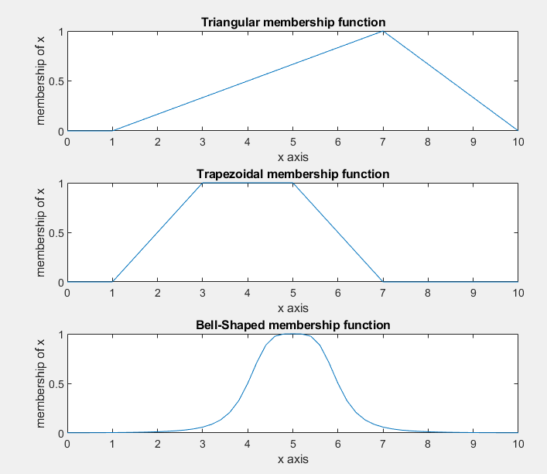

**Conclusion:**

**Reference:** https://www.youtube.com/watch?v=whIR88tAANE&list=PLJ5C_6qdAvBFqAYS0P9INAogIMklG8E-9&index=3

**Experiment No. 5:**

**Title: Use Fuzzy toolbox to model tip value based on service and food quality.**

**Aim:** Write down briefly about the importance/ applicability of fuzzy toolbox.

**Procedure and Results:** You are required to explain how fuzzy toolbox can be implemented.

Crisp Input

Crisp Output

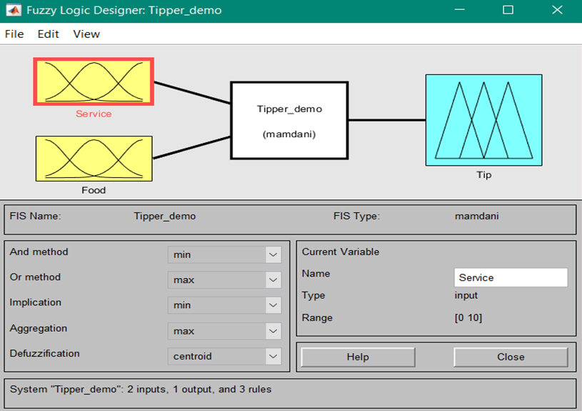

Input linguistic variables: Service (Poor, Good, Excellent) & Food (Rancid, Delicious)

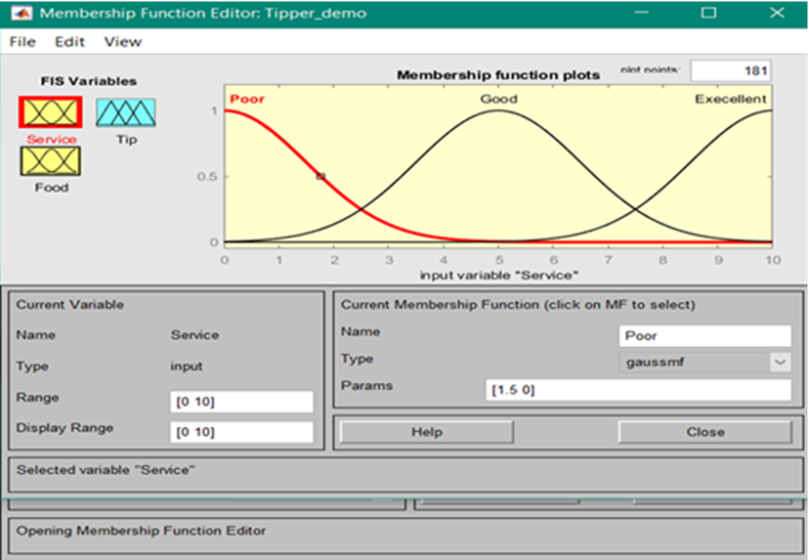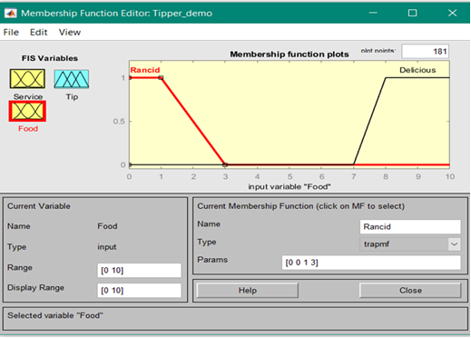

Output linguistic variables: Tip (Cheap, Average, Generous)

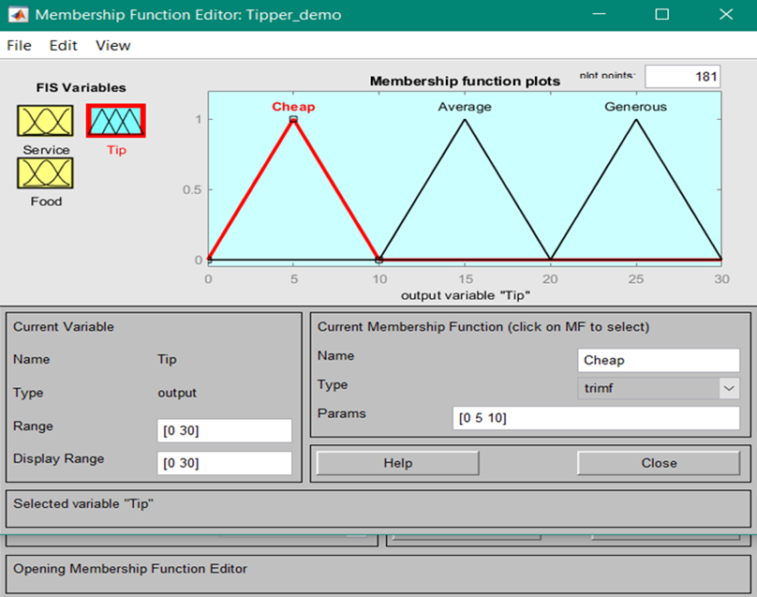

In general a compositional rule for inference involves the following procedure:

* Compute memberships of current inputs in the relevant antecedent fuzzy set of rule.
* If the antecedents are in conjunctive form, the AND operation is replaced by a minimum, if OR then by Maximum and similarly other operations are performed.
* Scale or clip the consequent fuzzy set of the rule by a minimum value found in step 2 since this gives the smallest degree to which the rule must fire.
* Repeat steps 1-3 for each rule in the rule base. Superpose the scaled or clipped consequent fuzzy sets formed by such a superposition. There are numerous variants of the defuzzification.

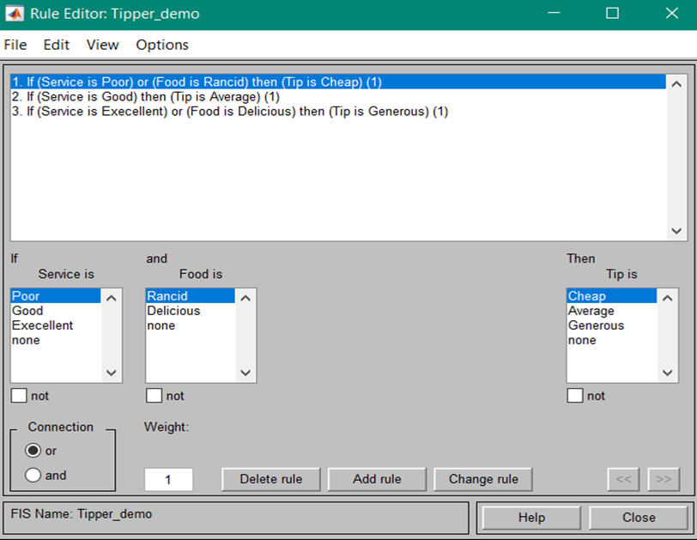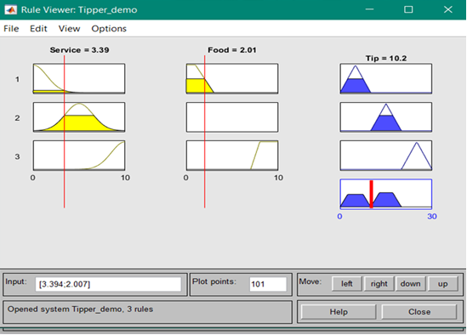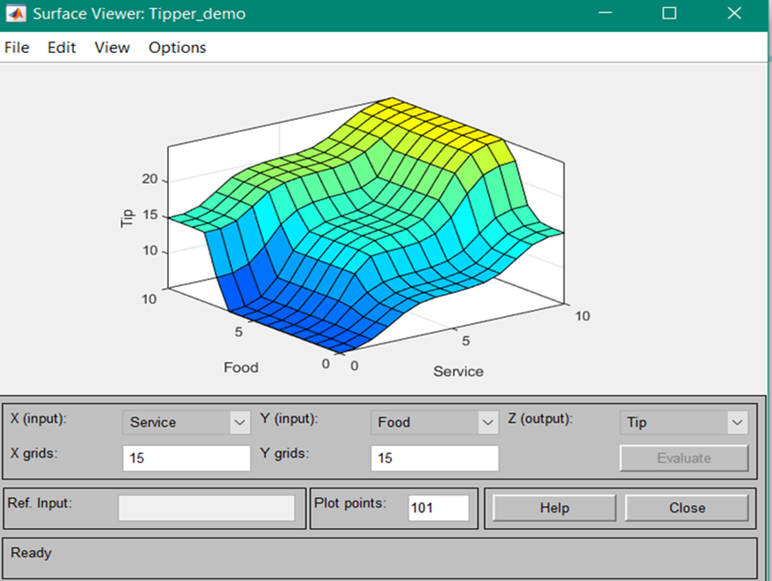

**Conclusion:**

**Reference:**

* https://www.youtube.com/watch?v=O348HnWPm7A&t=1s
* https://www.youtube.com/watch?v=wBrHEXkTero&t=20s
* https://www.youtube.com/watch?v=LupUhRJo_sU&t=3s

**Experiment No. 6:**

**Title: Implement FIS Editor.**

**Aim:** Write down briefly about the importance/ applicability of fuzzy editor.

**Procedure and Results:** You are required to explain how fuzzy editor can be implemented.

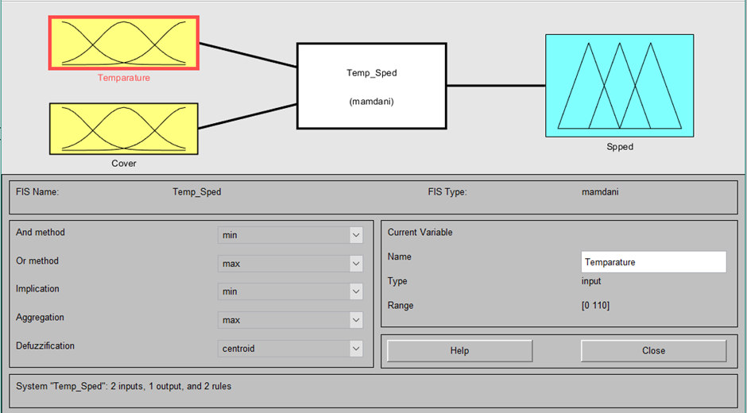

Input linguistic variables: Temperature (Freezing, Cool, Warm, Hot) & Cover (Sunny, Partly, Overcast)

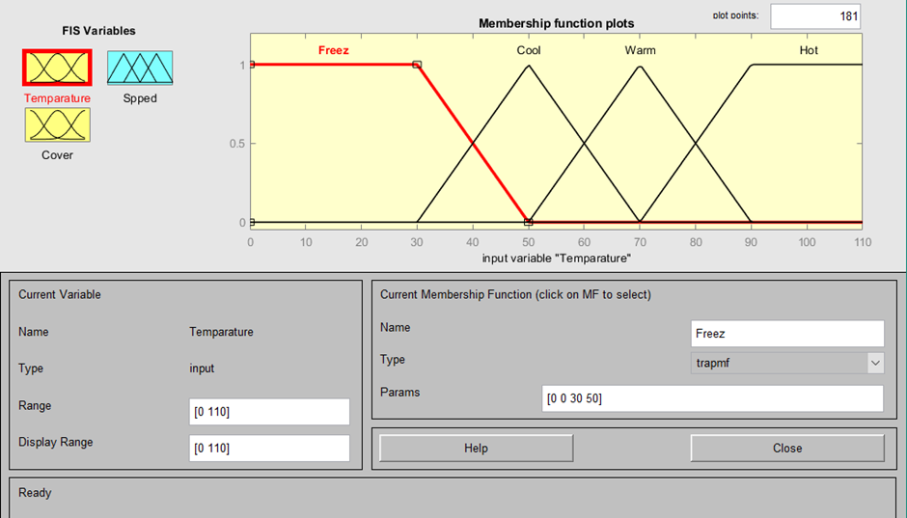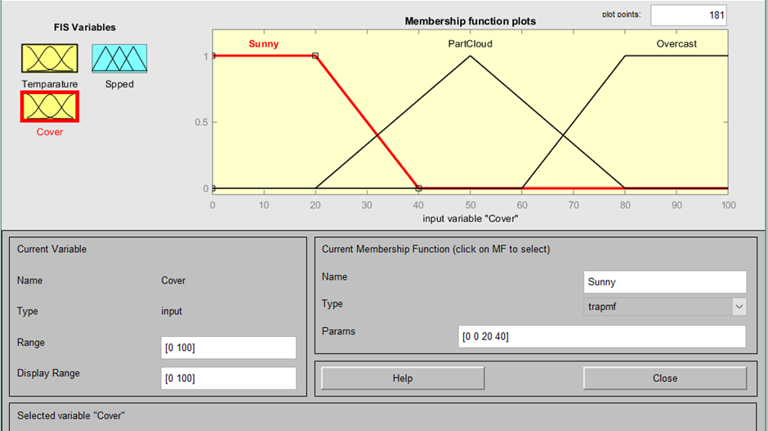

Output linguistic variables: Speed (Slow, Fast)

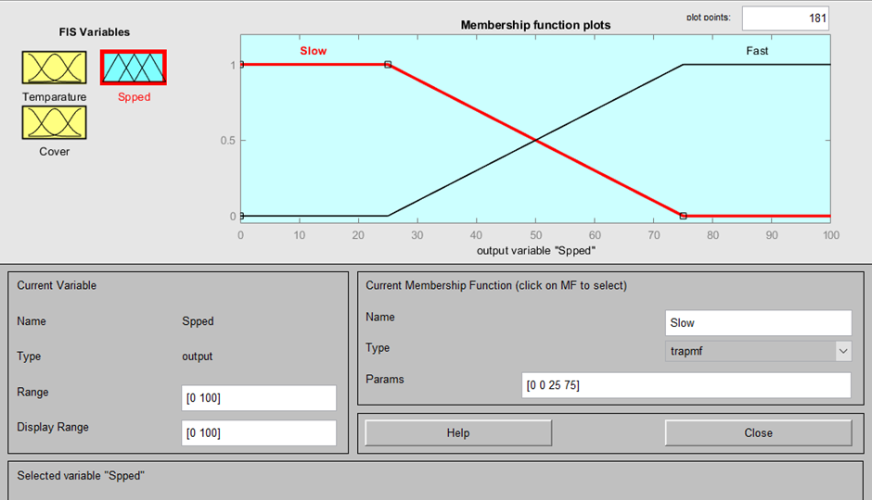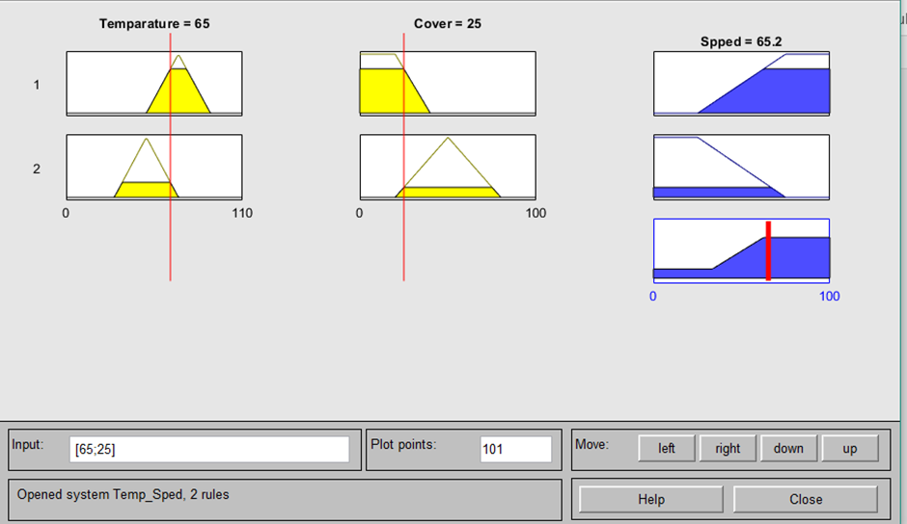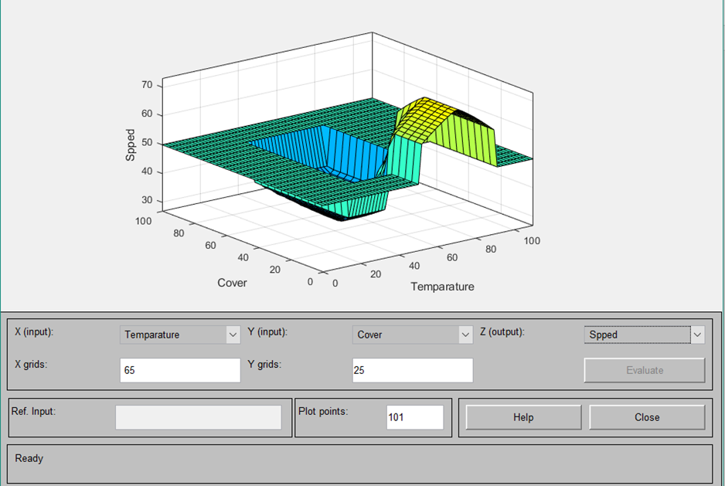

**Conclusion:**

**Reference:**

* https://www.youtube.com/watch?v=uBxWYTdF0UA

**Experiment No: 7:**

**Title: Write a MATLAB Program on Basic Operations of Genetic Algorithm.**

**Aim:** Write down briefly about the importance/ applicability of genetic algorithm.

**Theory:** Write it as taught in the class.

**Matlab Code:**

clc

clear all

close all

%generation of genes randomly

%generate 10 genes each of length 30 using binary encoding

pool = randi([0,1], 10, 30);

%fitness is decided based on summation of values for each gene

fitness = sum(pool,2);

%selection of best fittted genes

high_first = max(fitness);

for i = 1:10

if fitness(i) == high_first

a=i;

end

end

parent_one = pool(a,:);

disp('Parent 1:'), disp (parent_one)

high_second = max(fitness(fitness<max(fitness)));

for i = 1:10

if fitness(i) == high_second

a=i;

end

end

parent_two = pool(a,:);

disp('Parent 2:'), disp (parent_two)

%crossover is done at any random point

b = randi([1 , 30]);

for i = 1:30

if i <= b

child(i) = parent_one(i);

else

child(i) = parent_two(i);

end

end

disp('Crossover point:'), disp (b)

disp('Child after crossover:'), disp (child)

%mutation is done at any random point

c = randi([1 , 30]);

if child(c) == 0

child(c) = 1;

end

disp('Mutation point:'), disp (c)

disp('Child after mutation:'), disp (child)

**Results:**

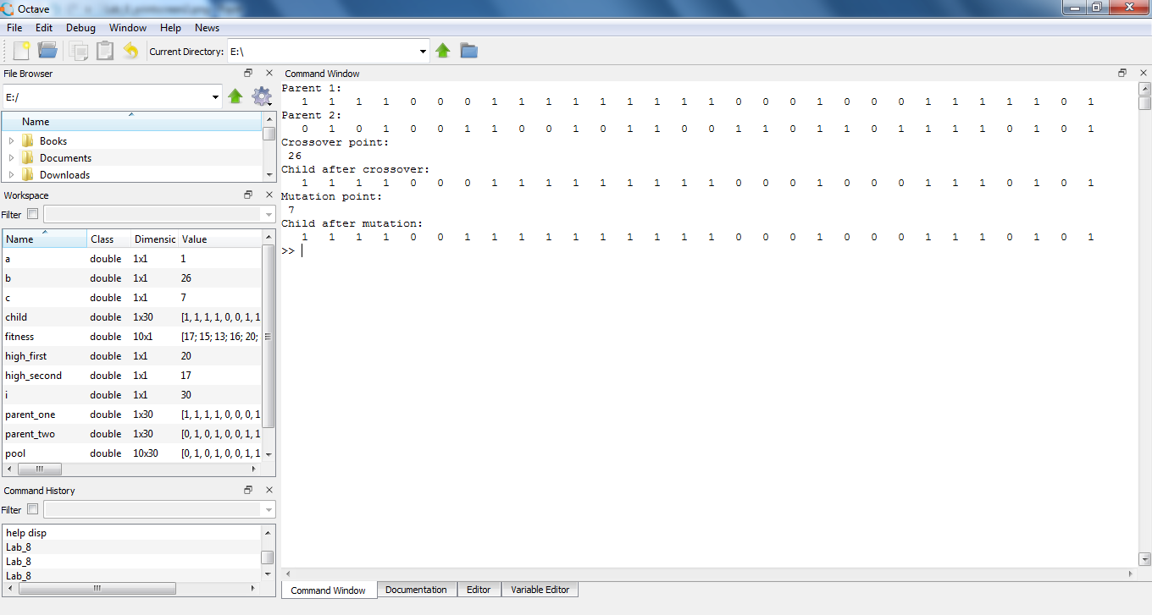

**Conclusion:**

**Reference:**

https://www.youtube.com/watch?v=mwXckn8up_U&list=PLsEIbHOtypISN0ZXjZ7Uhp0YwCToyrOLM&index=2

**Experiment No: 8:**

**Title: Basic Understanding of Prolog Programming.**

**Aim:** Write down briefly about the importance/ applicability of knowledge representation.

**Theory:** Write it as taught in the class.

**Facts:**

Pheonix is hot in summer.

Loss Angels is warm in winter.

Pheonix is warm in winter.

# Query:

1. Which city is hot in summer?
2. Which city is hot in summer and warm in winter?

**Code:**

weather(pheonix,hot,summer). weather(lossangles,warm,winter). weather(pheonix,warm,winter).

# Query:

weather(X,hot,summer). weather(X,hot,summer),weather(X,warm,winter).

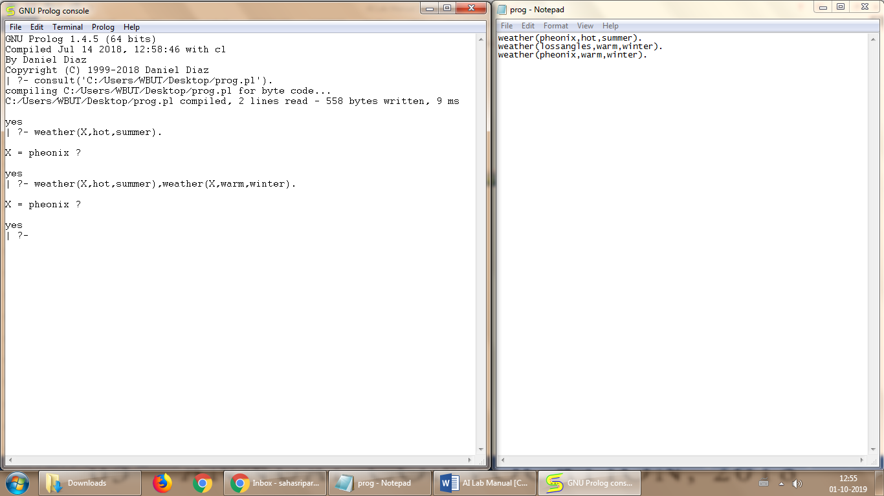

**Facts:**

1. Ram likes mango.
2. Seema is a girl.
3. Bill likes Cindy.
4. Rose is red.
5. John owns gold.

# Code:

likes(ram, mango).

likes(bill, cindy).

girl(seema).

red(rose).

owns(john, gold).

**Query:**

likes(ram,What).

likes(Who,cindy).

red(What).

owns(Who,What).

